LAB 1: Study of Basic Networking Commands.
Objective
- To become familiar with common networking commands used for troubleshooting and verification.
- To observe and interpret command outputs related to IP configuration, connectivity, routing, and name resolution.
- To document the results with appropriate screenshots/output descriptions.
Theory
Networking commands help diagnose connectivity problems, verify IP settings, inspect routing behavior, and test name resolution.
Tools such as ping and traceroute validate reachability and path, while ipconfig/ifconfig and netstat provide host-level configuration and session information.
Understanding these outputs is essential for network installation, operation, and troubleshooting.
Network Topology Diagram (if applicable)
Network Topology Diagram: Not applicable (commands are executed on a host).
(Insert figure here and label it properly as per your lab manual.)
Hardware/Software Requirements
- PC/Laptop with Windows or Linux operating system
- Command Prompt (Windows) or Terminal (Linux)
- Local network connection (LAN/Wi-Fi) and optional Internet connectivity

- PING
Purpose: Tests the reachability of a host on an Internet Protocol (IP) network and measures the round-trip time for messages sent from the originating host to a destination computer.
Command Syntax:
ping [host_name or ip_address]
Example Output Description: A successful ping returns four data packets, showing the time in milliseconds (ms) and Time-to-Live (TTL) for each reply. It concludes with packet statistics (Sent=4, Received=4, Lost=0). Failure (Lost > 0) indicates a network connectivity problem.
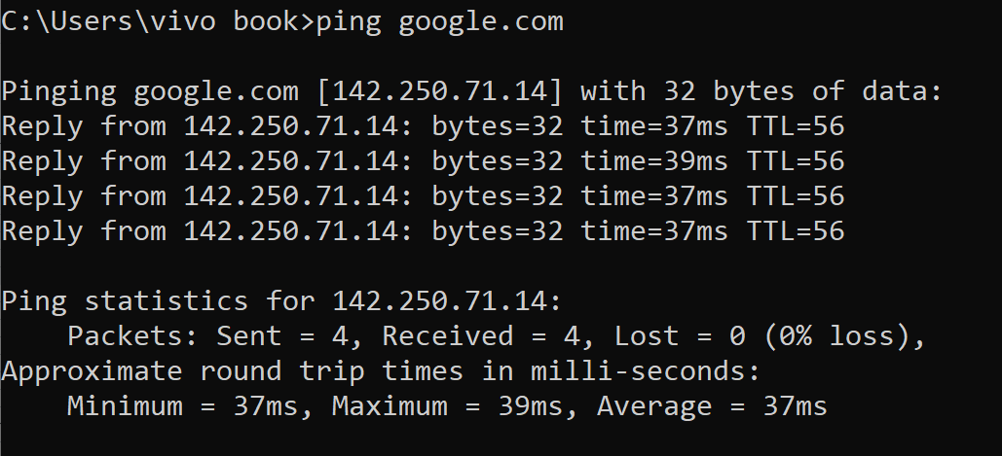
- IPconfig
Purpose: Displays basic IP address configuration information for the local Windows device and its network adapters.
Command Syntax (Basic):
ipconfig
Command Syntax (Detailed):
ipconfig /all
Output Description:
- The basic command displays the IPv4 Address, Subnet Mask, and Default Gateway for active adapters.
- The /all parameter provides detailed information, including DNS server addresses, MAC address (Physical Address), DHCP status, and IP address lease details.
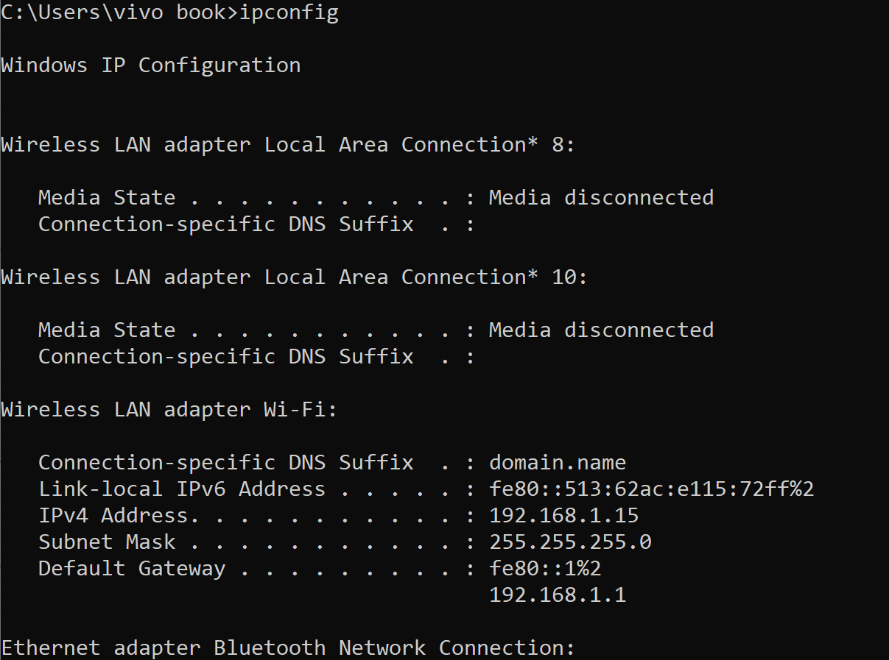
- GETMAC
Purpose: Retrieves the Media Access Control (MAC) address (a unique hardware identifier) for all network adapters on the local computer.
Command Syntax:
getmac
Output Description: The command returns the unique 48-bit Physical Address (MAC Address) and the associated Transport Name for each network device (connected or disconnected).
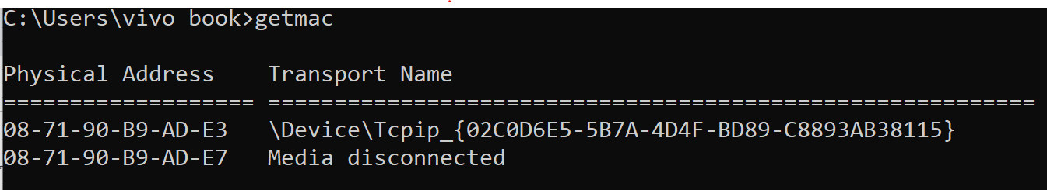

- HOSTNAME
Purpose: Displays the name of the local computer, which is used to identify the device on the local network.
Command Syntax:
hostname
Output Description: Outputs the configured hostname of the computer.
- NSLOOKUP
Purpose: Diagnostic tool used to query the Domain Name System (DNS) to obtain domain name or IP address mapping or other DNS records. It helps diagnose DNS infrastructure issues.
Command Syntax (Interactive Mode):
nslookup
(Once in interactive mode, you can type domain names like google.com or facebook.com to resolve them.)
Output Description: When run without parameters, it shows the Default DNS Server and its IP Address that the PC is currently using for name resolution. When resolving a domain, it shows the resolved IP Address.
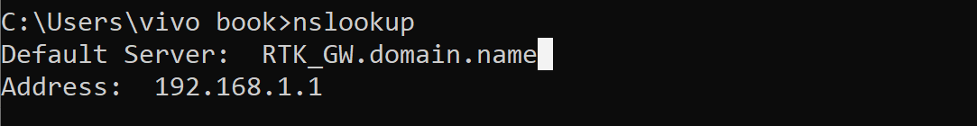
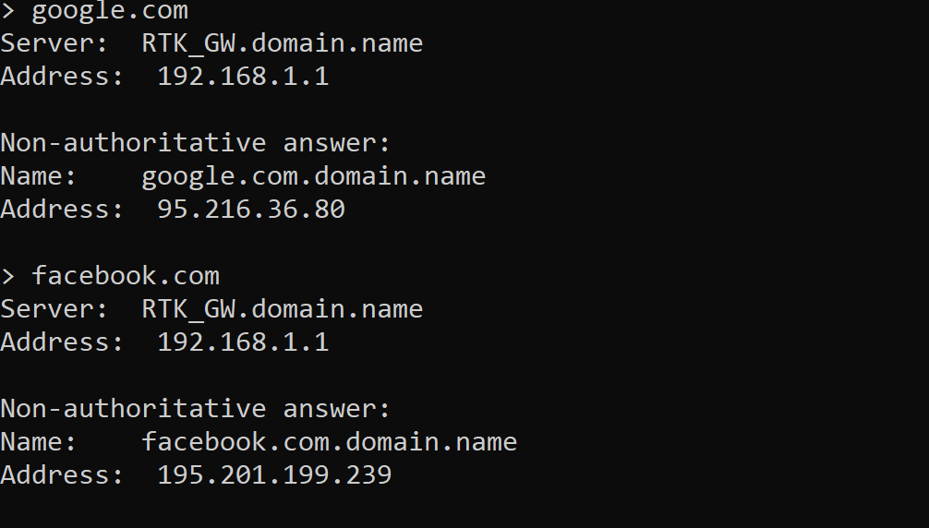
- TRACERT
Purpose: Traces the route a data packet takes to reach a destination host, displaying information about each router (hop) along the path.
Command Syntax:
tracert [host_name or ip_address]
Output Description: Displays a numbered list of intermediate routers, the round-trip time (in milliseconds) from the source to that router, and the router's IP address. This helps locate network latency or failure points.
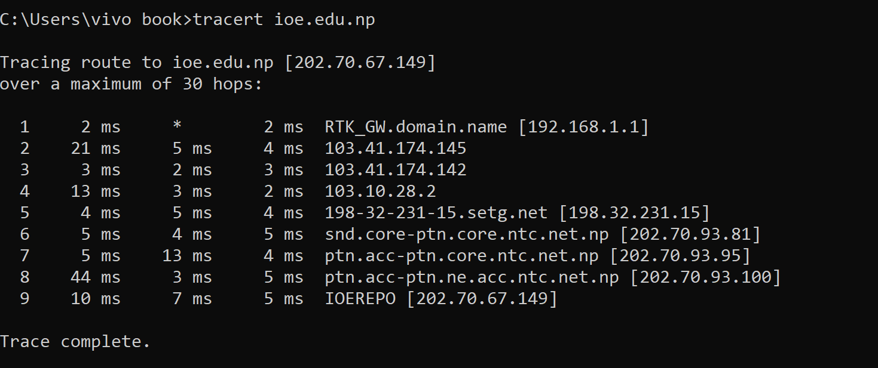

- NETSTAT
Purpose: Displays active TCP connections, ports on which the computer is listening, Ethernet statistics, the IP routing table, and other network statistics.
Command Syntax (Active Connections):
netstat
Output Description: The basic command shows active TCP connections, listing the Protocol (Proto), Local Address, Foreign Address, and the connection State (e.g., ESTABLISHED, LISTEN, TIME_WAIT).
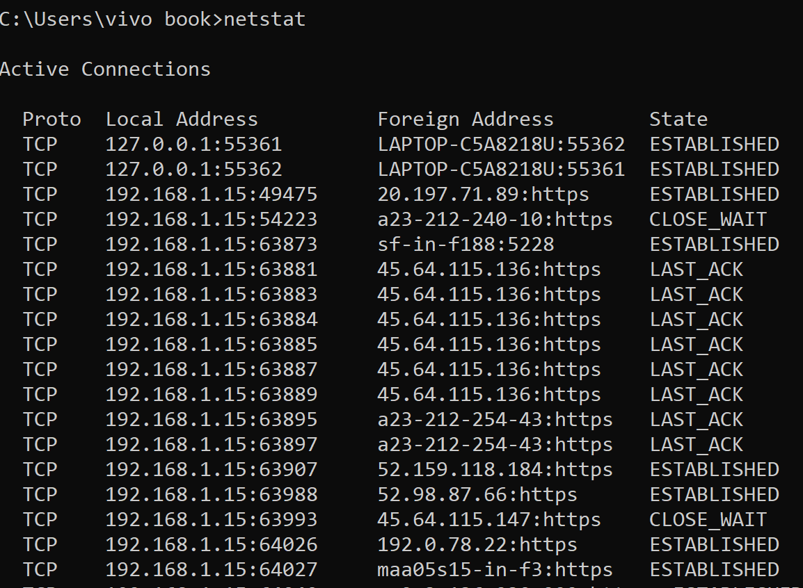
- ARP
Purpose: Displays and modifies the Address Resolution Protocol (ARP) cache, which maps IP addresses to physical (MAC) addresses for devices on the local network segment.
Command Syntax (Display Cache):
arp /a
Output Description: Displays the current ARP cache tables for all interfaces, listing the Internet Address (IP), Physical Address (MAC), and Type (dynamic or static).
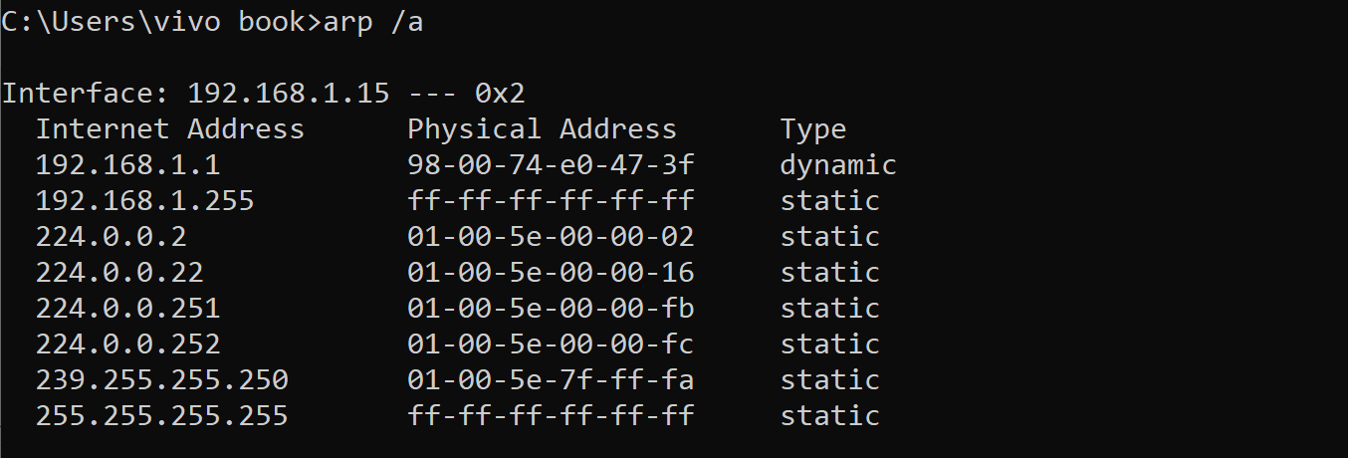

- SystemInfo
Purpose: Displays a detailed list of configuration information for the Windows PC, including hardware and software details.
Command Syntax:
systeminfo
Output Description: Provides exhaustive details such as OS version, Host Name, Product ID, System Manufacturer/Model, CPU type, RAM configuration, and installation dates.
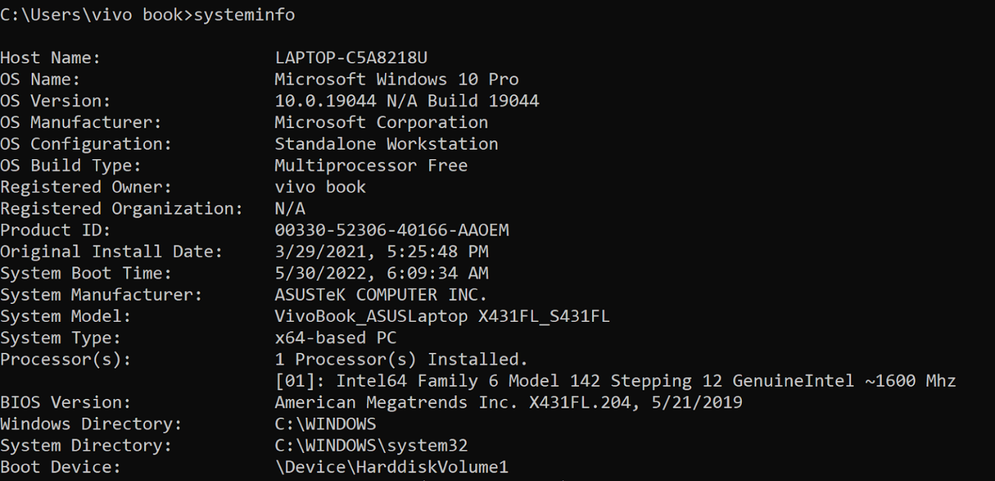
- PathPing
Purpose: Combines the features of ping and tracert, providing statistics on network latency and packet loss over a period of time at each hop in the route to the destination.
Command Syntax:
pathping [host_name or ip_address]
Output Description: Initially traces the route like tracert, then sends packets to all routers in the path for several seconds, providing a final report on latency and packet loss per hop.
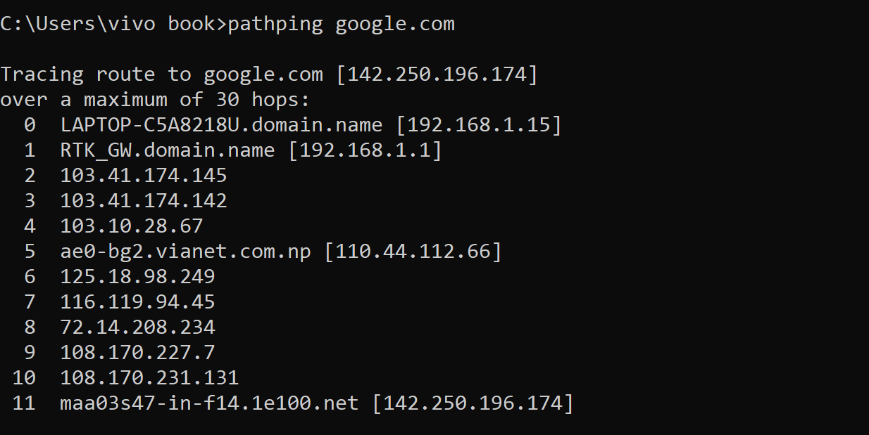
Conclusion
This lab introduced essential networking commands used to verify host configuration, test connectivity, observe routing paths, and validate DNS resolution. These tools form the foundation of practical network troubleshooting.

LAB 2: Configuration and Verification of a Network Switch Using Cisco Packet Tracer.
Objective
- To configure basic settings on a Cisco switch using CLI in Packet Tracer.
- To verify switch operation using appropriate show commands.
- To test end-device connectivity through the switch.
Theory
A switch operates primarily at OSI Layer 2 (Data Link) and forwards frames using MAC address learning.
Basic switch configuration includes device identity (hostname), security (passwords), management IP address (SVI), and saving configuration.
Verification commands confirm VLAN status, interface states, and the MAC address table.
Network Topology Diagram
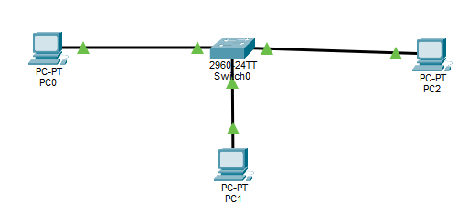
Hardware/Software Requirements
- Cisco Packet Tracer (installed on PC)
- 1 x Cisco 2960/2950 Switch (Packet Tracer device)
- 2 x PCs (Packet Tracer end devices)
- Console access (Packet Tracer CLI)
Configuration steps
Step 1: configuring the PCs.
All the PCs must be in the same subnet (192.168.10. x) to talk to the switch.
- Click PCO> Desktop tab > IP configuration.
- Set IP to 192.168.10.1 and subnet mask to 255.255.255.0.
- Click PC1 > desktop tab > IP configuration.
- Set IP to 192.168.10.2 and subnet mask to 255.255.255.0.
- Click PC2 > desktop tab > IP configuration.
- Set IP to 192.168.10.3 and subnet mask to 255.255.255.0.
Verification and testing
Method 1: Link Lights
Look at your workspace. If the circles on the cables are Green, the physical connection is active. If they are Amber, wait 30 seconds for spanning tree protocol to turn them green.
Method 2: Ping test (Functional verification)
- Click on PCO.
- Go to the Desktop tab and open the Command prompt.
- Type ping 192.168.10.2 and press enter.
- You should see “Reply from 192.168.10.2”, which confirms the switch is correctly configured.
- You can repeat same for other’s pc.
Result:
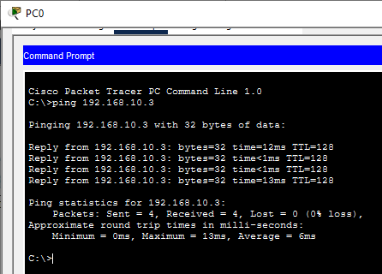
Conclusion
In this lab, a Cisco switch was configured with basic security and management settings. Verification commands and connectivity tests confirmed correct VLAN 1 management configuration and proper Layer 2 switching behavior.

LAB 3: Configuration and Verification of a Network Router Using Cisco Packet Tracer.
Objective
- To configure a Cisco router with IP addressing on interfaces.
- To enable interfaces and verify the configuration using show commands.
- To test routing connectivity between two separate LANs.
Theory
A router operates mainly at OSI Layer 3 (Network) and forwards packets based on destination IP address and routing table information.
Basic router setup includes setting host identity, interface IP addresses, enabling interfaces, and verifying status.
Successful inter-LAN communication requires correct interface configuration and end-device default gateways.
Network Topology Diagram
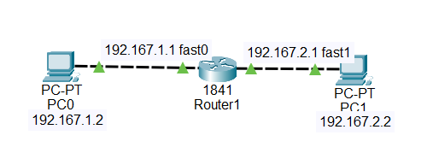
Hardware/Software Requirements
- Cisco Packet Tracer
- 1 x Cisco Router (e.g., 1941/2911)
- 2-4 x PCs (end devices)
- Copper straight-through/serial cables as needed
Configuration Steps (with commands/code)
Step 1: Configure PCs in LAN1 (192.168.1.0/24)
- Click PC0 > Desktop tab > IP Configuration.
- Set:
  - IP Address: 192.168.1.10
  - Subnet Mask: 255.255.255.0
  - Default Gateway: 192.168.1.1
(If you have more PCs in LAN1, use 192.168.1.11, 192.168.1.12, etc.)
Step 2: Configure PCs in LAN2 (192.168.2.0/24)
- Click PC1 > Desktop tab > IP Configuration.
- Set:
  - IP Address: 192.168.2.10
  - Subnet Mask: 255.255.255.0
  - Default Gateway: 192.168.2.1
(If you have more PCs in LAN2, use 192.168.2.11, 192.168.2.12, etc.
Step 3: Configure Router R1 (CLI)
- Click Router (R1).
- Go to the CLI tab.
- Press Enter to start.
- Type the following commands:
enable
configure terminal
hostname R1
no ip domain-lookup
enable secret class
service password-encryption
interface gigabitEthernet 0/0
ip address 192.168.1.1 255.255.255.0
no shutdown
exit
interface gigabitEthernet 0/1
ip address 192.168.2.1 255.255.255.0
no shutdown
exit
end
write memory

Verification and Testing
Method 1: Verify Router Interfaces
- Click R1 > CLI.
- Type:show ip interface brief
Method 2: Verify Routing Table
- Click R1 > CLI.
- Type:
show ip route
Method 3: Ping Test (Inter-LAN Connectivity)
- Click PC0 > Desktop tab > Command Prompt.
- Type:
ping 192.168.1.2
Output/Results
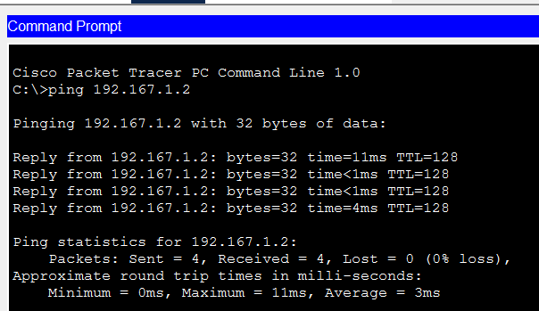
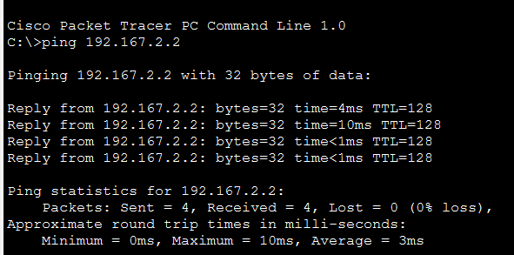
Conclusion
This lab verified basic router configuration and demonstrated inter-network communication between two LANs. Correct interface addressing and proper default gateway settings enabled successful routing.

LAB 4: Configuration and Implementation of Static Routing Protocol.
Objective
- To configure static routes on routers to enable communication between multiple networks.
- To verify static routing using show ip route and connectivity tests.
- To understand next-hop and exit-interface based static routes.
Theory
Static routing is a manual method of defining routes in a router’s routing table.
It is simple and predictable but does not automatically adapt to topology changes.
Static routes are commonly used in small networks, stub networks, or as backup routes.
Network Topology Diagram
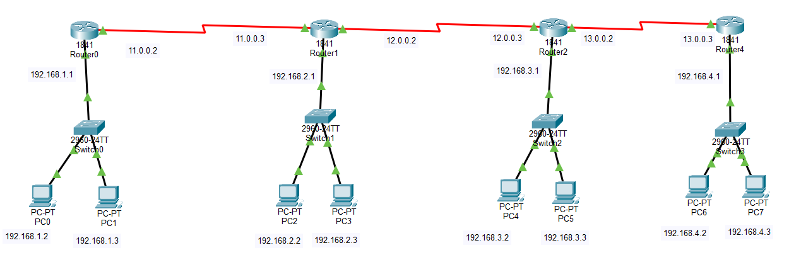Hardware/Software Requirements
- Cisco Packet Tracer
- 4 x Routers
- 4 x Switches
- 8-4 x PCs
- Appropriate cabling
Configuration Steps
Step 1: Configuring the PCs
Each LAN uses a different subnet.
- Click PC0 > Desktop > IP Configuration
  - IP: 192.168.1.2
  - Subnet Mask: 255.255.255.0
  - Default Gateway: 192.168.1.1
- Click PC1
  - IP: 192.168.1.3
  - Subnet Mask: 255.255.255.0
  - Default Gateway: 192.168.1.1
- Click PC2 / PC3
  - IPs: 192.168.2.2, 192.168.2.3
  - Gateway: 192.168.2.1
- Click PC4 / PC5
  - IPs: 192.168.3.2, 192.168.3.3
  - Gateway: 192.168.3.1
- Click PC6 / PC7
  - IPs: 192.168.4.2, 192.168.4.3
  - Gateway: 192.168.4.1
Step 2: Configuring the Routers
- Assign IP addresses to router LAN interfaces:
  - Router0: 192.168.1.1
  - Router1: 192.168.2.1
  - Router2: 192.168.3.1
  - Router3: 192.168.4.1
- Assign serial interface IPs as shown in the topology:
  - Router0–Router1: 11.0.0.2 / 11.0.0.3
  - Router1–Router2: 12.0.0.2 / 12.0.0.3
  - Router2–Router3: 13.0.0.2 / 13.0.0.3
- Enable all interfaces using no shutdown.
Verification and Testing
Method 1: Link Lights
If the cable indicators are green, the physical connections are active. If amber, wait a few seconds for the interfaces to initialize.
Method 2: Ping Test (Functional Verification)
- Click PC0 > Desktop > Command Prompt.
- Type ping 192.168.4.2 and press Enter.
- Successful replies confirm proper router configuration and connectivity across the network.
Output/Result:
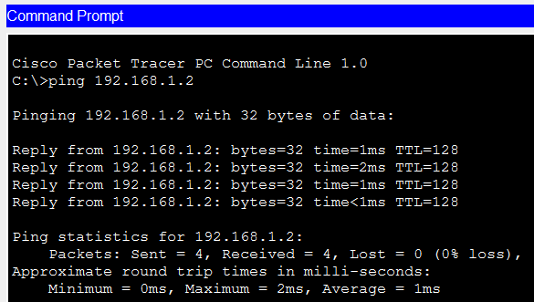
Fig 2: ping from pc0 to pc1
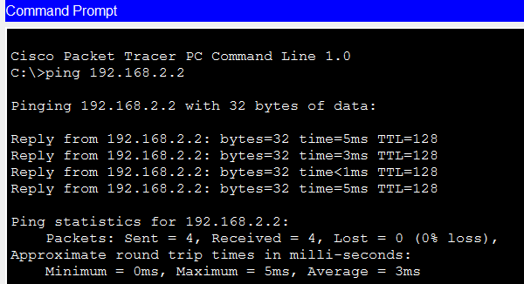
Fig 3: ping from pc2 to pc3
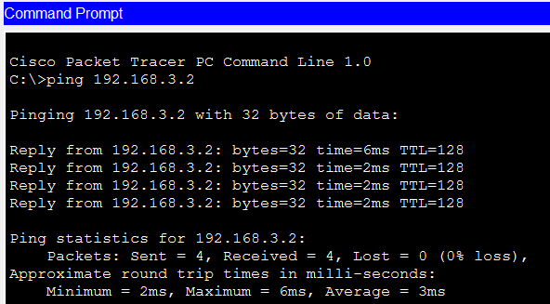
Fig 4: ping from pc4 to pc5
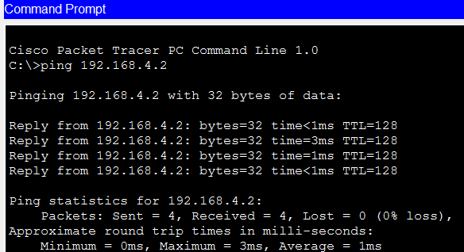
Fig 5: ping from pc6 to pc7
Conclusion
Static routes were configured to enable communication between separate LANs through a router-to-router link. Verification outputs confirmed that routes were correctly installed and end-to-end connectivity was achieved.

LAB 5: Configuration and Analysis of Dynamic Routing Protocols.
Objective
- To configure a dynamic routing protocol and observe learned routes.
- To compare dynamic routing behavior (RIP v2 and OSPF) in terms of routing table entries and convergence indications.
- To verify connectivity using ping/traceroute and routing-table inspection.
Theory
Dynamic routing protocols automatically learn and update routes when network topology changes.
RIP v2 is a distance-vector protocol that uses hop count as metric (max 15 hops).
OSPF is a link-state protocol that builds a topology database and uses cost as a metric.
Dynamic routing reduces manual configuration effort in multi-router networks.
Network Topology Diagram (if applicable)
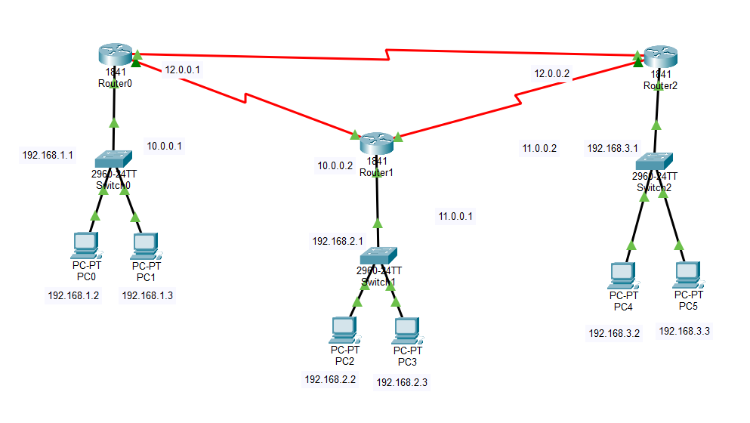Hardware/Software Requirements
- Cisco Packet Tracer
- 3 x Routers (recommended for observation)
- 3 x Switches and 2 x PCs
- Appropriate cabling
Configuration Steps
Step 1: Configuring the PCs. Each PC must be in a different subnet.
- Click PC > Desktop tab > IP Configuration.
- Assign IP address and subnet mask as per the network.
- Set the default gateway to the router LAN IP.
Step 2: Configuring the Routers
- Assign IP addresses to all router interfaces.
- Enable interfaces using the no shutdown command.
Step 3: Configuring Dynamic Routing (RIP v2)
- Open Router CLI.
- Configure RIP by advertising connected networks.
- Disable auto-summary.
Verification and Testing
Method 1: Routing Table Check. Use show ip route to verify dynamically learned routes.
Method 2: Ping Test (Functional Verification)
- From any PC, open Command Prompt.
- Ping a PC in another network.
- Successful reply confirms dynamic routing.
Result:
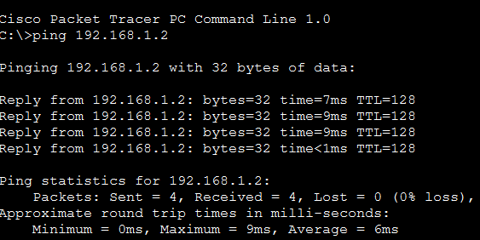
Fig 2: ping from pc0 to pc1
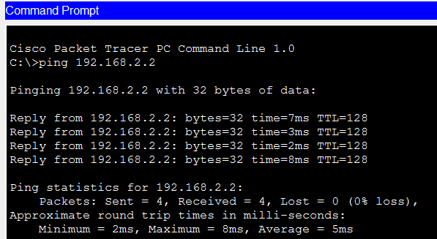
Fig 4: Ping from pc2 to pc3
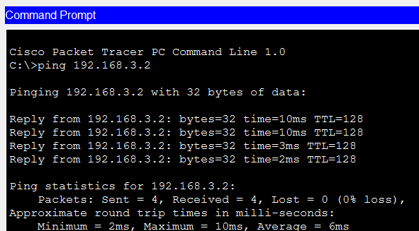
Fig 5: ping from pc4 to pc5
Conclusion
Dynamic routing was configured and analyzed using RIP v2 and OSPF. The routing table outputs and verification commands demonstrated automatic route learning and differences in route markings, metrics, and neighbor formation behavior.

LAB 7: To Configure and Test a Domain Name System (DNS) Server.
Objective
- To configure a DNS server in Cisco Packet Tracer.
- To create DNS records (A records) for hostname-to-IP mapping.
- To test name resolution from client devices using ping/nslookup.
Theory
DNS translates domain names into IP addresses.
Clients query a DNS server to resolve names. Correct DNS operation requires a properly addressed server, enabled DNS service, and correct client DNS settings.
Network Topology Diagram (if applicable)
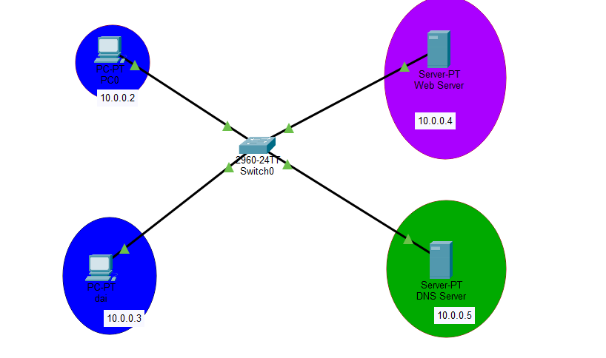Hardware/Software Requirements
- Cisco Packet Tracer
- 1 x Server (DNS service)
- 1 x Switch
- 1-2 x PCs (clients)
Configuration Steps:
Step 1:Configure IP Addresses
Ensure all devices have correct static IP addresses and point to the DNS server (Server-PT DNS Senior, 10.0.0.5).
- PC0: 10.0.0.2, Subnet Mask: 255.0.0.0, DNS Server: 10.0.0.5
- PC-PT Admin: 10.0.0.3, Subnet Mask: 255.0.0.0, DNS Server: 10.0.0.5
- Server-PT Web Server: 10.0.0.4, Subnet Mask: 255.0.0.0, DNS Server: 10.0.0.5
- Server-PT DNS Senior: 10.0.0.5, Subnet Mask: 255.0.0.0, DNS Server: 10.0.0.5
- The Switch0 (2960-24TT) operates at Layer 2 and does not require an IP configuration for this lab.
Step 2: Configure the DNS Server
Click on Server-PT DNS Senior and navigate to its services tab.
- Go to Services DNS.
- Turn the DNS Service to On.
- Add the following resource records as Type A Records:
  - SUdip.com with IP address 10.0.0.4
  - PC0 with IP address 10.0.0.2
  - PC-PT Admin with IP address 10.0.0.3
- Click Add after each entry to save it.
Step3: Configure the Web Server
Click on Server-PT Web Server and ensure the HTTP service is active.
- Go to Services HTTP.
- Ensure HTTP and HTTPS services are turned On.
Verification and Testing
Method 1: Ping Test
- Open Command Prompt on PC0.
- Type ping pc1.example.com. You should see “Reply from 192.168.10.2”.
- Repeat for other PCs to confirm name resolution.
Result:
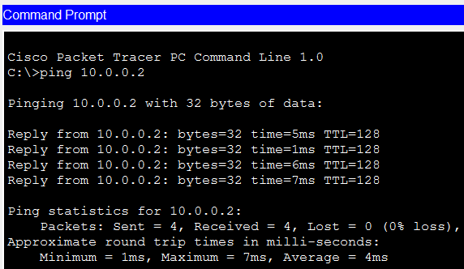
Fig 2: ping from pc0 to pc1
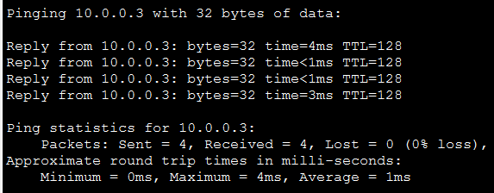
Fig 3: Ping from pc1to pc0
Conclusion
A DNS server was configured and tested in Packet Tracer. Hostname resolution worked correctly after adding DNS records and setting the client DNS address.

LAB 8: To Configure and Test a File Transfer Protocol (FTP) Server.
Objective
- To configure an FTP server in Cisco Packet Tracer.
- To create FTP user credentials and permissions.
- To test FTP login and file transfer from a client PC.
Theory
FTP is an application-layer protocol used to transfer files between a client and server.
FTP typically operates on TCP port 21 for control. In lab environments, FTP demonstrates client-server communication and authentication.
Network Topology Diagram (if applicable)
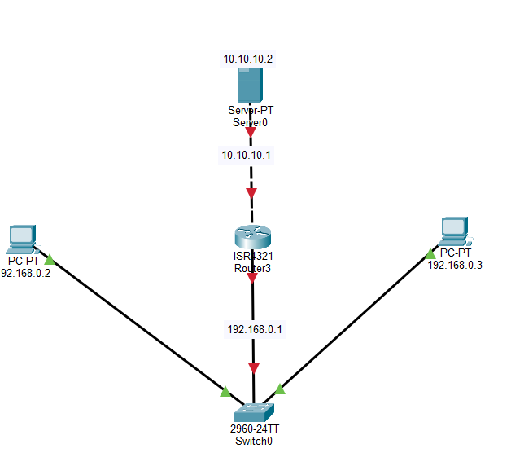
Hardware/Software Requirements
- Cisco Packet Tracer
- 1 x Server (FTP service)
- 1 x Switch
- 1 x PC (FTP client)
Configuration Steps:
Step 1: Configuring IP address
- Click PC0 > Desktop tab > IP configuration.
- Set IP to 192.168.0.2, subnet mask to 255.255.255.0, and Default Gateway to 192.168.0.1.
- Click PC1 > desktop tab > IP configuration.
- Set IP to 192.168.0.3, subnet mask to 255.255.255.0, and Default Gateway to 192.168.0.1.
- Click the FTP Server > Desktop tab > IP configuration.
- Set IP to 10.10.10.2, subnet mask to 255.0.0.0, and Default Gateway to 10.10.10.1
Step 2: Configuring the Router Interfaces
Configure the router interfaces using the CLI or Config tab and ensure they are administratively up (no shutdown).
- Configure the fa0/0 interface with IP 192.168.0.1 and subnet mask 255.255.255.0.
- Configure the fa0/1 interface with IP 10.10.10.1 and subnet mask 255.0.0.0
Step 3: Configuring the FTP Service
Enable the FTP service on the server and create a user account.
- Click on the FTP server > Services tab > FTP.
- Turn the FTP Service to On.
- Create a user (e.g., username cisco, password cisco) and grant all permissions (Write, Read, Delete, Rename, List).
- Click Add
Verification and Testing
Method 1: Ping test (Functional verification)
- Click on PC0.
- Go to the Desktop tab and open the Command prompt.
- Type ping 10.10.10.2 and press enter.
- You should see “Reply from 10.10.10.2”, which confirms network connectivity across the router.
Method 2: FTP Test
- Access FTP server using client from any PC.
- Verify successful file upload and download.
- Check server logs for connection and transfer records.
Result:
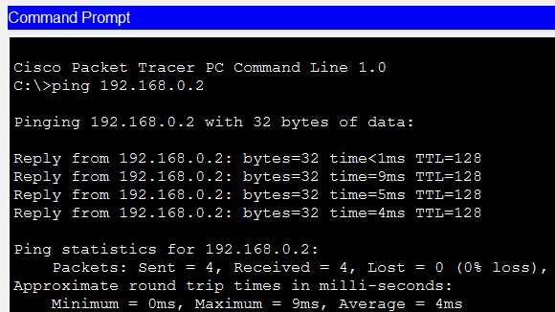
Fig 2: ping from pc0 to pc1
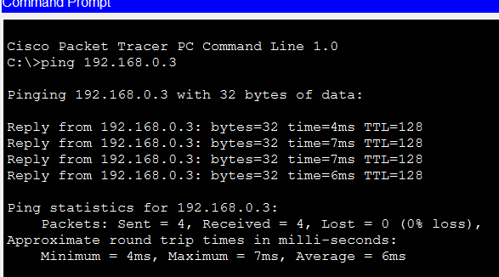
Fig 3: Ping from pc1to pc0
Conclusion
The FTP server was configured and tested successfully. Client authentication and file transfer commands demonstrated FTP operation within Packet Tracer.
LAB 9:To Configure and Verify Virtual Local Area Networks (VLANs) Communication.
Objective
- To create VLANs and assign switch ports to VLANs.
- To configure trunk links for VLAN traffic between switch and router/switches.
- To enable inter-VLAN routing (Router-on-a-Stick) and verify VLAN communication.
Theory
VLANs logically segment a switch into multiple broadcast domains.
Access ports belong to a single VLAN, while trunk ports carry multiple VLANs using IEEE 802.1Q tagging.
Inter-VLAN communication requires a Layer 3 device to route traffic between VLANs.
Network Topology Diagram
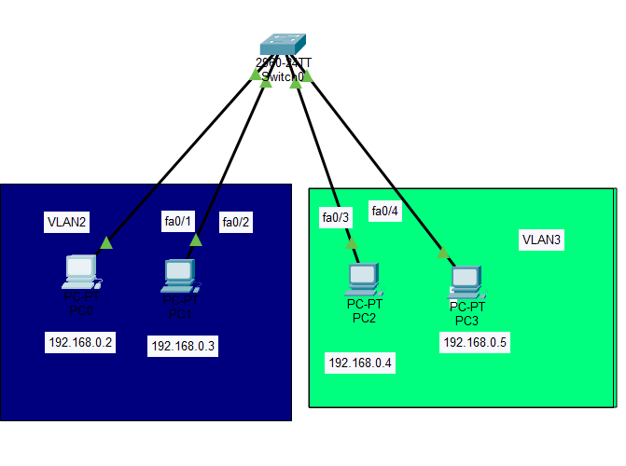
Hardware/Software Requirements
- Cisco Packet Tracer
- 1 x Switch (or 2 switches for trunk demonstration)
- 2-4 x PCs (at least one PC per VLAN)
- Appropriate cabling
Configuration Steps:
Step 1: Configuring VLANs on the Switch
- Access switch CLI: enable → configure terminal
- Create VLANs:
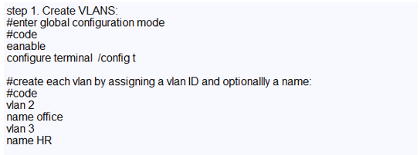
3.Assign ports to VLANs:
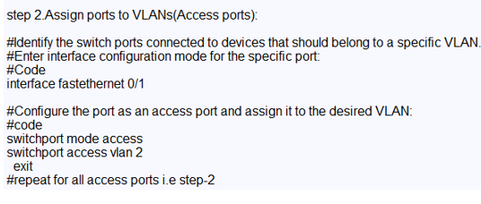
4.Exit and save configuration: end and write memory
Step 2: Configuring the PCs
- PC0: IP 192.168.0.2, Subnet mask 255.255.255.0, Default gateway 192.168.0.1
- PC1: IP 192.168.0.3, Subnet mask 255.255.255.0, Default gateway 192.168.0.1
- PC2: IP 192.168.0.4, Subnet mask 255.255.255.0, Default gateway 192.168.0.1
- PC3: IP 192.168.0.5, Subnet mask 255.255.255.0, Default gateway 192.168.0.1
Verification and Testing
Method 1: Intra-VLAN Communication
- From PC0, open Command Prompt.
- Ping PC1: ping 192.168.10.2 → Should reply.
Result:
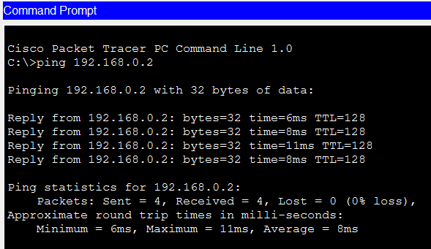
Fig 2 : ping from pc0 to pc1
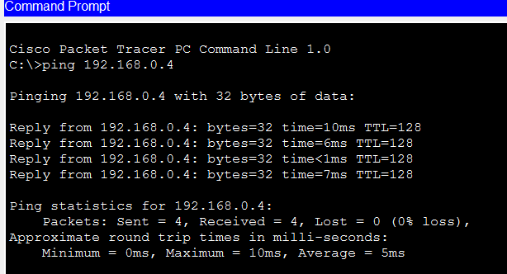
Fig 3: ping from pc2 to pc3
Conclusion
VLANs were created and verified on the switch. Trunk configuration and routing subinterfaces enabled communication between hosts in different VLANs.

